Musical Periods: The History of Classical Music
Music has come a long way in the last thousand years or so, and we’re going to tell you how! From Gregorian Chants to Mozart’s sonatas, we’re going to give you a brief history of the 6 Musical Periods and how they’ve each contributed to music today.
The 6 musical periods are classified as Medieval, Renaissance, Baroque, Classical, Romantic, and 20th/21st Century, with each fitting into an approximate time frame.
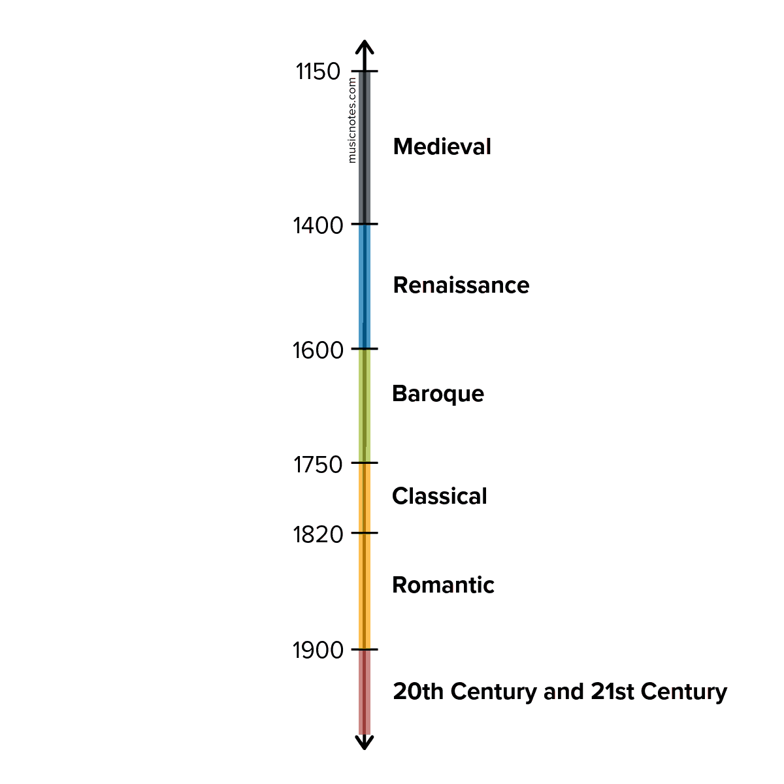
Medieval (1150 – 1400)
Though we can assume that music began far before 1150, the Medieval period is the first in which we can be sure as to how music sounded during this time. Most notated manuscripts from the Medieval period came from the church or places connected to the church, and so most pieces have a religious subject.
Instruments used during this time included the flute, the recorder, and plucked string instruments, like the lute. Early versions of the organ and fiddle also existed.
Perhaps the most known type of music to come out of the Medieval period was the Gregorian Chant. Gregorian Chants were monophonic, (a single, unaccompanied melodic line) and most commonly sung by monks. Take a moment to listen to the Gregorian Chant below. Notice the notation in the background as well, which has also drastically changed over time.
VIDEO: https://www.youtube.com/watch?v=kK5AohCMX0U
Though the monophonic style was a staple in the Medieval period, it’s important to note that polyphonic vocal genres also developed in this time. Polyphony is the use of multiple independent voice types, as opposed to the one melody line in monophonic singing.
It can be concluded that the introduction of harmony began in the Medieval period.
Though a large portion of the music written in this era is not attributed to any author, John Dunstable, Adam de la Halle, Phillippe de Vitry, Guillaume de Machaut, and Francesco Landini were all notable composers in this period.

Renaissance (1400 – 1600)
The Renaissance brought significantly increased amounts of harmony and polyphony into music, as most composers were focused on choral music.
The Renaissance was a golden age for choral composition, especially in a capella compositions.
Religious music continued to flourish throughout the entire Renaissance period, including new forms such as masses, anthems, psalms, and motets. Some composers of sacred music began to adopt secular forms (such as the madrigal) towards the end of the period. Take a moment to listen to “The Silver Swan,” a famous choral piece still sung today by composer Orlando Gibbons.
VIDEO: https://www.youtube.com/watch?v=tzxvONTljhU
Instrumentation became more prominent during this period, with the introduction of:
- Early brass instruments: slide trumpet, cornet, valveless trumpet, sackbut
- Adapted string instruments: viol, rebec, lyre, lute, guitar
- The harpsichord
- Small percussion instruments: triangle, tambourine, bells, small drums
- Early woodwind instruments: reed pipe, bagpipe, transverse flute, recorder
The second half of the Renaissance period was incredibly influential, as composers became to move away from the modal system of harmony and towards the organization of major and minor scales.
The strong sensation of each piece having a definitely tonal center (or key) became commonplace in the Renaissance period.
Notable composers of the Renaissance include William Byrd, John Dowland, Orlando Gibbons, Giovanni Pierluigi da Palestrina, and Thomas Tallis.

Baroque (1600 – 1750)
Expanding upon the end of the Renaissance period, the Baroque period saw the creation of writing music in a particular key. However, the Baroque period is commonly known for complex pieces and intricate harmonies. Still, this period laid the groundwork for the next 300 years of music.
The idea of the modern orchestra was born, along with opera, the concerto, sonata, and cantata. Choral music was no longer king, as composers turned to compose instrumental works for various ensembles. “Classical” music gradually began to work its way into society, being played outdoors at dinner parties and special functions, or as a spectacle in the form of opera.
George Frederick Handel‘s Water Music is an excellent example of a typical Baroque period piece, composed for King George and performed on the River Thames.
VIDEO: https://youtu.be/Kuw8YjSbKd4
As instrumental pieces became more prominent, individual instruments advanced drastically. Many new instruments emerged, such as the oboe, bassoon, cello, contrabass, and fortepiano (an early version of the piano). The string family of the Renaissance was replaced with stronger sounds from the violin, viola, and cello. The invention of the harpsichord flourished, and all existing woodwind and brass instruments were updated and advanced. The Baroque period also introduced stronger percussion with instruments like the timpani, snare drum, tambourine, and castanets.
Early Baroque composers included Claudio Monteverdi, Alessandro Scarlatti, Henry Purcell, and Jean Baptiste Lully, while later Baroque composers included Johann Sebastian Bach, George Frederick Handel, Georg Philipp Telemann, Jean-Philippe Rameau, Dominico Scarlatti, and Antonio Vivaldi. These later composers contributed substantially in the transition to Classical music.

Classical (1750 – 1820)
The term “Classical Music” has two meanings
- The broader meaning includes all Western art music from the Medieval era to the 2000s.
- The specific meaning refers to the music from the 1750s to the early 1820s.
We are discussing the specific meaning in this section.
The Classical period expanded upon the Baroque period, adding a majorly influential new song form: the sonata. This period also saw the development of the concerto, symphony, sonata, trio, and quartet.
The Classical period is most known for it’s compulsion for structural clarity in music.
Though this period didn’t add any majorly new instrumentation, the harpsichord was officially replaced with the piano (or fortepiano). Orchestras increased in size, range, and power, and instrumentation overall had a lighter, more evident texture than Baroque music, making it less complicated.
Notable composers from the Classical period include musical giants Joseph Haydn, Ludwig van Beethoven, Franz Schubert, and of course, Wolfgang Amadeus Mozart.
Listen to one of Mozart‘s most famous pieces, “Rondo Alla Turca” from his Piano Sonata No. 11 performed by Musicnotes Signature Artist, Rousseau.
VIDEO: https://www.youtube.com/watch?v=aeEmGvm7kDk
Romantic (1820 – 1900)
Beethoven and Schubert bridged the gap between the Classical and Romantic periods of music. Just as one might assume from the word “romantic,” this period took Classical music and added overwhelming amounts of intensity and expression. As the period developed, composers gradually let go of heavily structured pieces and gravitated towards drama and emotion.
The Romantic era was the golden age of the virtuoso, where the most difficult music would be performed with nonchalant ease.
Instrumentation became even more prominent, with orchestras growing to higher numbers than ever before. Composers experimented in new ways, trying out unique instrumentation combinations and reaching new horizons in harmony. Public concerts and operas moved away from the exclusivity of royalty and riches and into the hands of the urban middle-class society for all to enjoy.
The Romantic period was also the first period where national music schools began to appear. This era produced some of music’s most adored composers, including Hector Berlioz, Frederic Chopin, Felix Mendelssohn, Robert Schumann, Franz Liszt, Johannes Brahms, Peter Ilyich Tchaikovsky, and Richard Wagner. The very end of the Romantic period also brought about composers Gustav Mahler, Richard Strauss, Giacomo Puccini, Jean Sibelius, Camille Saint-Saëns, Gabriel Fauré, and Sergei Rachmaninoff.
Take a moment to listen to Chopin‘s “Nocturne in E-flat Major (Opus 9 No. 2)” and compare it to Mozart‘s”Rondo Alla Turca.”
VIDEO: https://www.youtube.com/watch?v=p29JUpsOSTE
20th Century and 21st Century (1900 – Current)
20th Century and 21st Century can be broken down into even smaller periods.
- Impressionist: 1890 – 1925
- Expressionist: 1908 – 1950
- Modern: 1890 – 1975
- Postmodern: 1930 – present
- Contemporary: 1945 – present
However, these sub-genres are normally lumped into one large category since there are so many diverse and opposing styles.
The 20th and 21st centuries can only be described as free reign for composers.
Each period we’ve described up until the 20th and 21st centuries had a general set of guidelines and characteristics that most composers followed. Over time, composers have been pulling further and further away from rules and restrictions into what is ultimately now a place of complete free reign. Classical music is now a place for the ultimate experimentation, and though it may not be as popular in 2018 as it was in 1800, it certainly has not disappeared.
Prolific composers in this period include Igor Stravinsky, Béla Bartók, Dmitri Shostakovich, Claude Debussy, Maurice Ravel, Gustav Holst, Arnold Schoenberg, and many more.
Possibly one of the most famous classical pieces of music ever was composed during this time: “Clair de Lune” by Claude Debussy.
VIDEO: https://www.youtube.com/watch?v=WNcsUNKlAKw
…

Classical music has come a long way, and countless composers have contributed to making it what it is today. Perhaps what we’ve learned more than anything is that classical music is one thing: timeless. We still look back to the beginning from time to time and remember the beautiful music so many people made. We’re thankful for their hard work, for the wonder they gave us, and the gift of classical music that always keeps giving!
Source:
https://www.musicnotes.com/now/news/musical-periods-the-history-of-classical-music/

